Name: Aman sain

SAP ID: 500107367

Roll no.: R2142220418

Batch: DevSecOps B1

Lab Exercise 5- Building a Docker Image for an HTML App Using Nginx

- Setup You will need:

  - Docker installed on your machine.

  - A simple HTML file for the app.

- Step 1: Create the HTML File

Create a directory for your HTML app and place an index.html file in it.

mkdir nginx-html-app

cd nginx-html-app
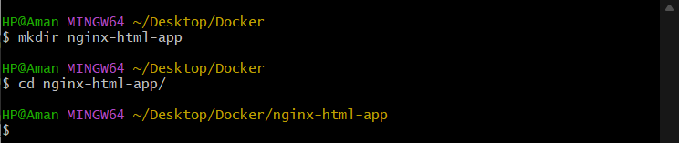
Inside the nginx-html-app directory, create the HTML file.
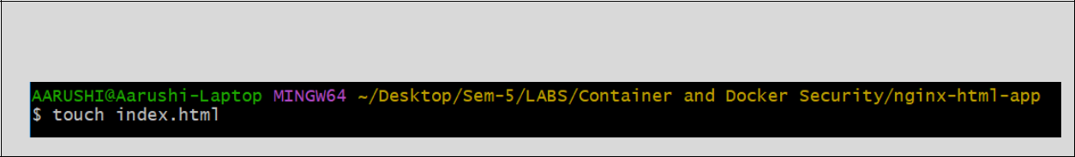

touch index.html

Edit the index.html file with the following content (or any custom HTML content you want):


<!DOCTYPE html>

<html>

<head>
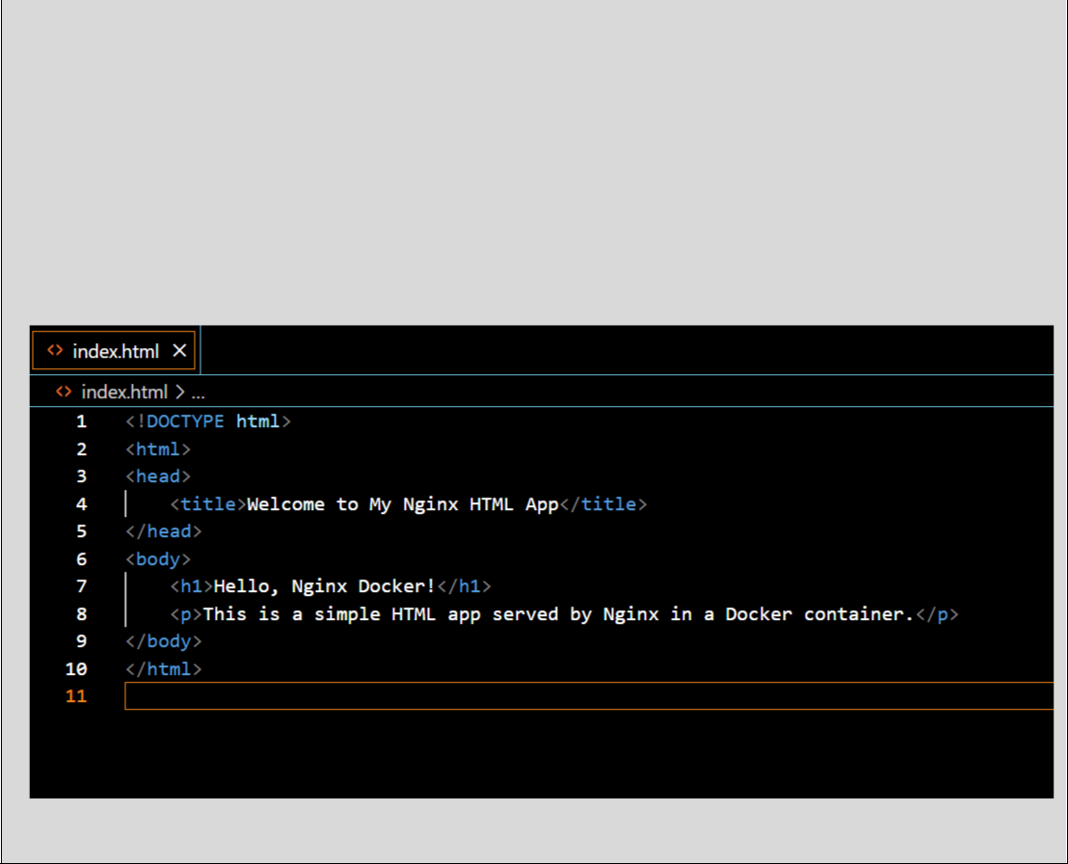
<title>Welcome to My Nginx HTML App</title>

</head>

<body>

<h1>Hello, Nginx Docker!</h1>

<p>This is a simple HTML app served by Nginx in a Docker container.</p> </body>

</html>

3. Step 2: Create a Dockerfile

In the same directory, create a Dockerfile. This file will define how to build the Docker image using Nginx as the base image.
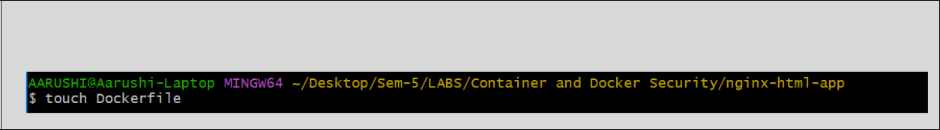

touch Dockerfile

Edit the Dockerfile and add the following content:


FROM nginx:latest

COPY index.html /usr/share/nginx/html/

EXPOSE 80

4. Step 3: Build the Docker Image

Now that you have the Dockerfile and index.html, it’s time to build the Docker image.

Run the following command to build the image, giving it a tag (e.g., nginx-html-app):

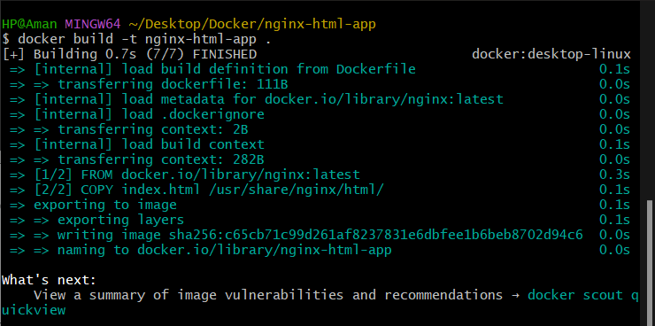
docker build -t nginx-html-app .
Docker will use the Nginx base image, copy your index.html into the appropriate directory, and build the image.

5. Step 4: Run the Docker Container

After building the image, you can run the container with the following command:

docker run -d -p 8080:80 nginx-html-app

This command runs the container in detached mode (-d) and maps port 8080 on your host machine to port 80 inside the container, where Nginx is serving your HTML app.

6. Step 5: Verify

Open a browser and go to http://localhost:8080. You should see your HTML page with the message “Hello, Nginx Docker!”.
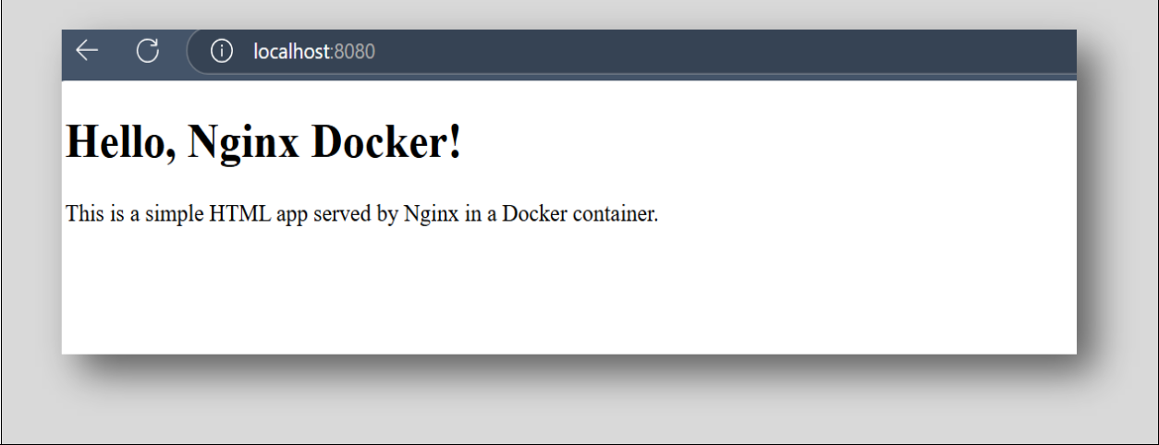

7. Step 6: Stop and Remove the Container

Once you're done, you can stop and remove the container:

docker ps # to see running containers
docker stop <container-id>
docker rm <container-id>